CIS 5400 Final Project

FIT Campus Tour Mobile Application

Bernice Templeman

2015

**The FIT Campus Tour App**

This is an application that uses the lessons from CIS 5400. It uses the following API from Cordova: Accelerometer, Camera, Capture, Events, File Permissions, Geolocation, Media, and Splash Screen.

It also uses the JQuery Mobile interface library to enhance the Graphical User Interface of the Application.

**The App:** There is an icon with a picture of the Botanical Garden. I changed the default icon and resized my picture to the appropriate sizes. (Screen 1)

When the Application opens a Splash Screen of the Botanical Garden is displayed. This uses the Cordova function from chapter 16 to display a splash screen. To change the default splash screen, I added a picture to the application directories and resized it to the different screen sizes. (Screen 2)

An event message is displayed for the Cordova “onBodyLoad” function from Cordova chapter 1. This function registers an event listener that calls the “onDeviceReady” function when the device is ready. (Screen 3)

When the device is ready, an event message is displayed to let the user know the application is ready. (Screen 4)

**Home:** The “Home” screen of the application displays a static google map of the FIT campus with markers at different locations. (Screen 5)

* “Start” and “Finish” buttons are used to display the user’s current location. This uses the Cordova Cookbook function from 11.2 to display the longitude and latitude. It watches the device’s location. (Screen 6)
* Location buttons display the Location’s name, longitude and Latitude. (Screen 7)
* A random location number is displayed based on a function that uses the Cordova Accelerometer. (Screen 8)
* Favorite Location Buttons: “Show”, “+” and “-“, which enable the user to select their favorite location number. This is saved in local storage and will be there the next time the user uses the app. (Screen 9)
* Header and Footer have links to home, back, and other pages.

**Info:** Is a list of the locations (Screen 10) which are linked to an individual page for each location with a recording about the location using the Media API and an image of the location. On each individual location page has the following buttons: “Play Audio”, “Pause Audio”, “Stop Audio” and “Resume”. (Screens 11-18)

**Video:** User can make a video with the Capture API and displays the most recent video. (Screen 19)

**Photo:** User can take a picture with the Camera API and display the most recent photo. (Screen 20)

**Dynamic Map:** Is a dynamic map of the FIT campus that also shows the users location. It has a “Show Map” button to display the Map. You can zoom in & out on this map. (Screens 21-22)

**About:** Is a description of the App and Contact information. (Screens 23-24)

**Screen Shots 1-4:**

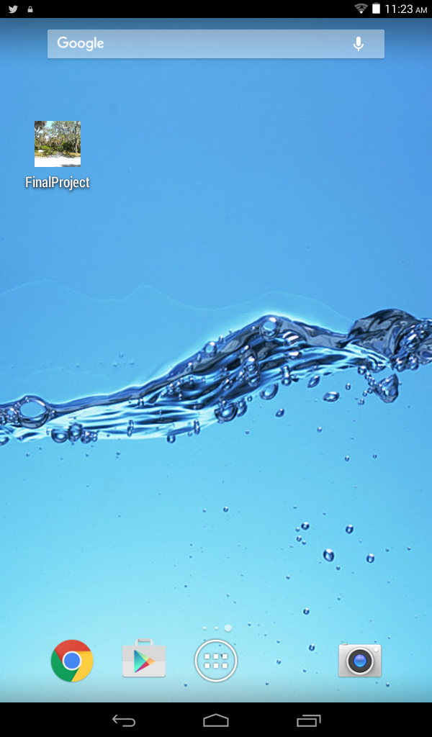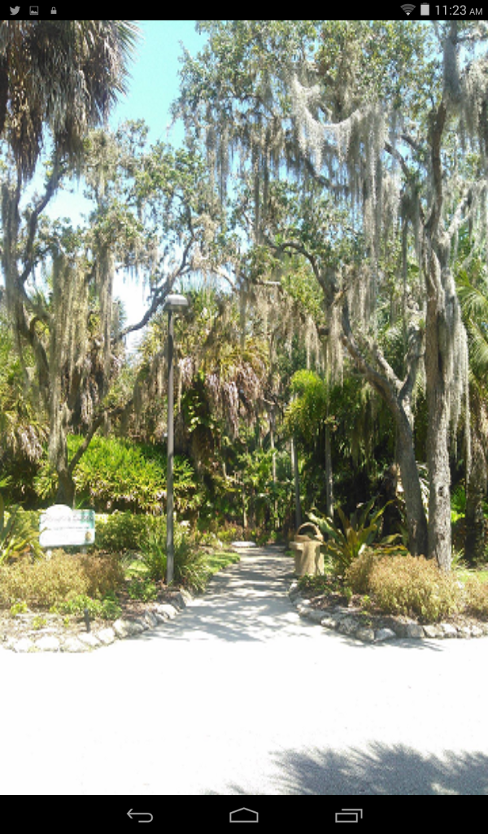

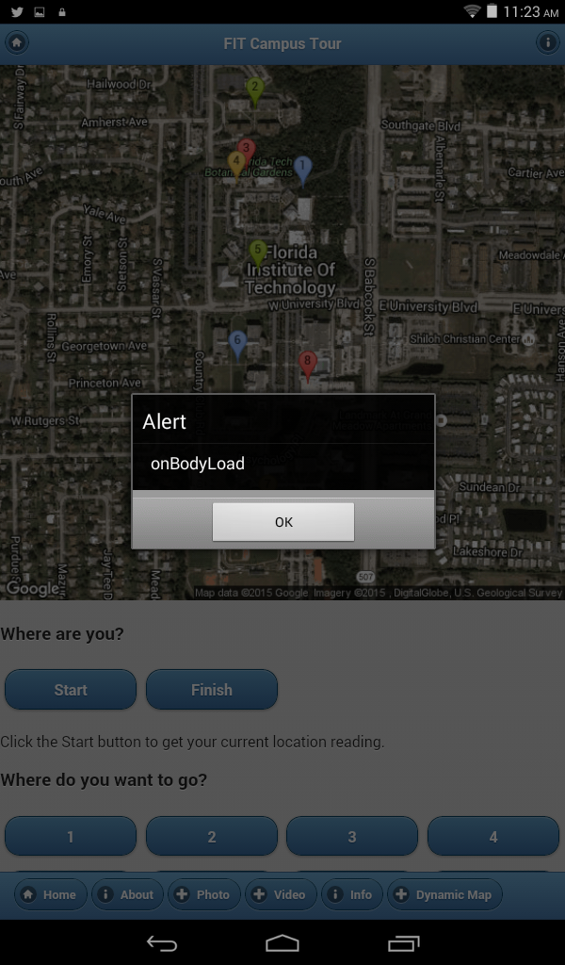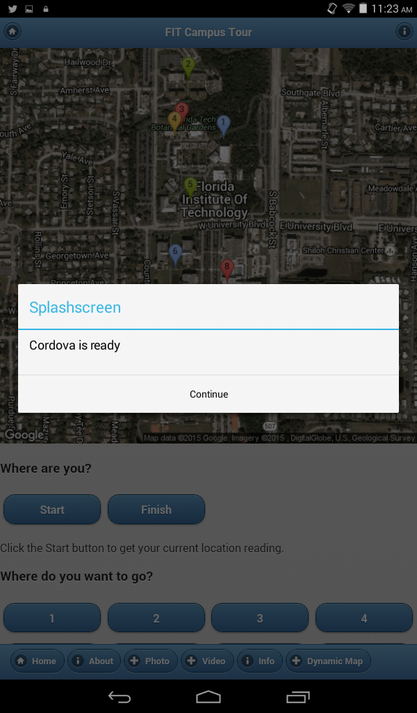

**Screen Shots 5-8:**

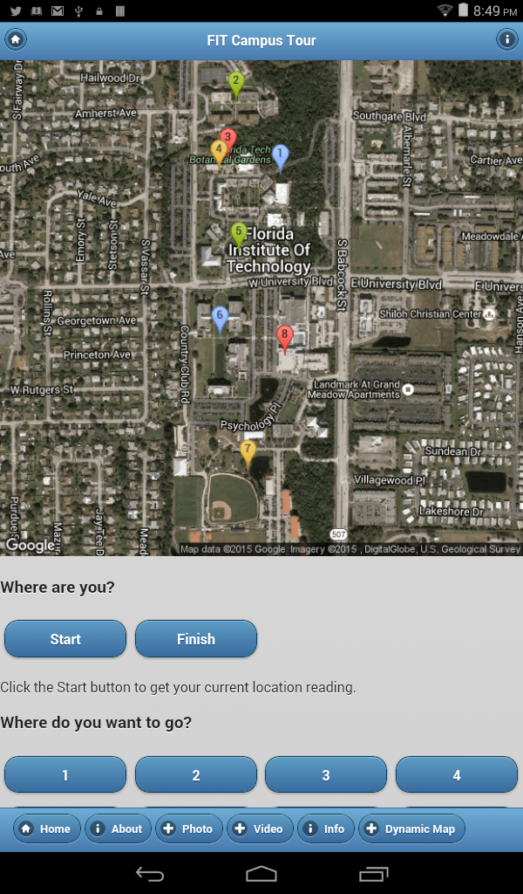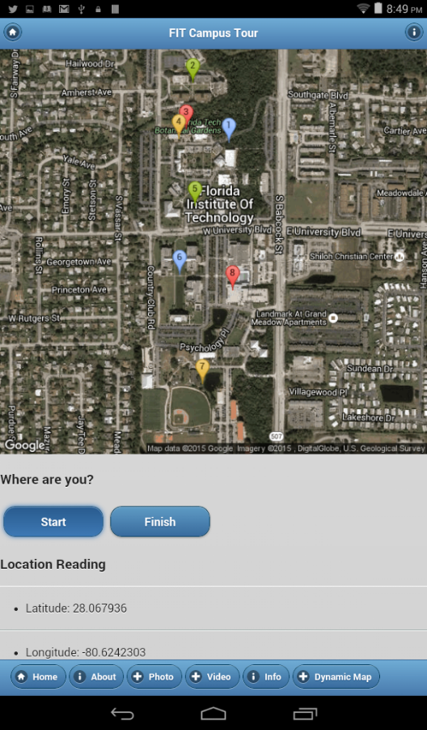 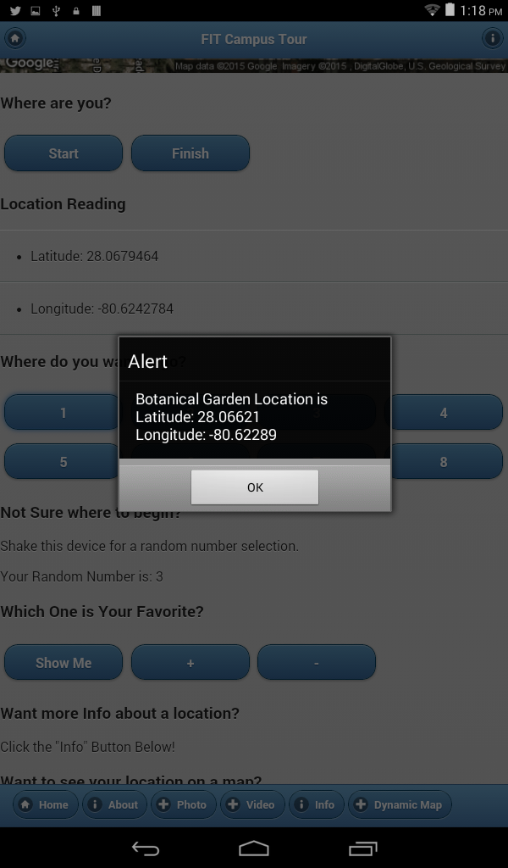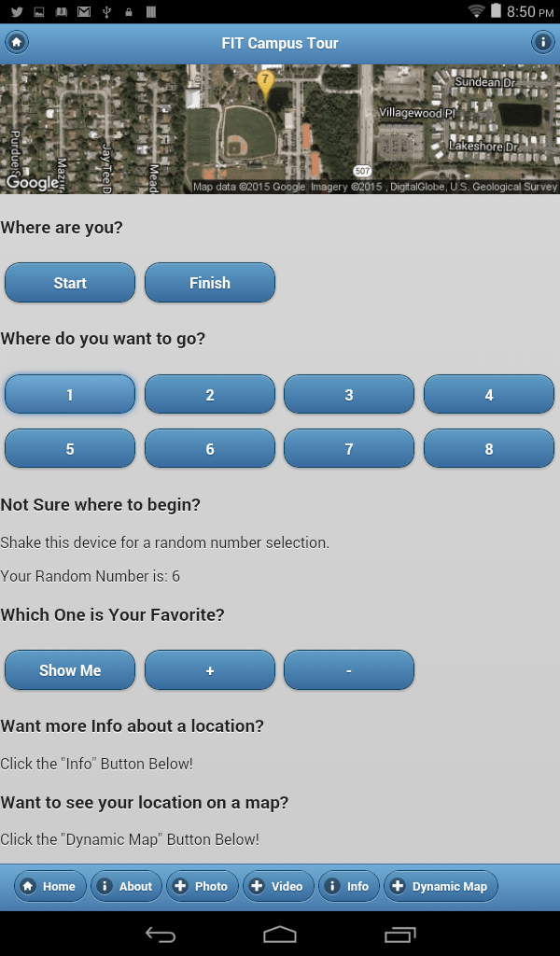

**Screen Shots 9-12:**

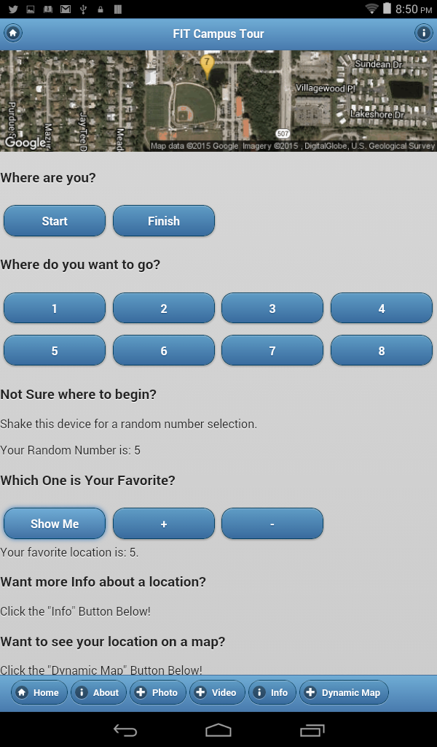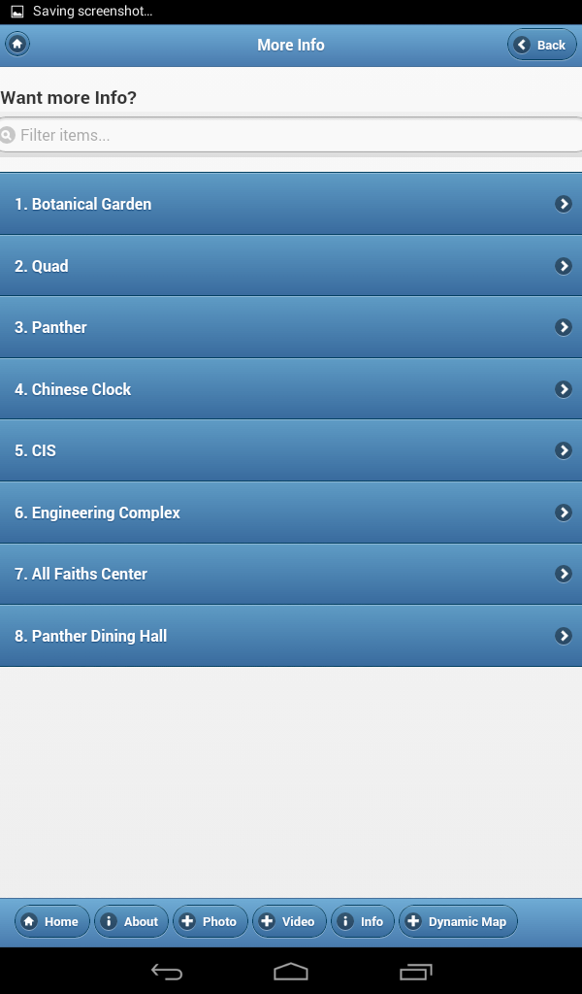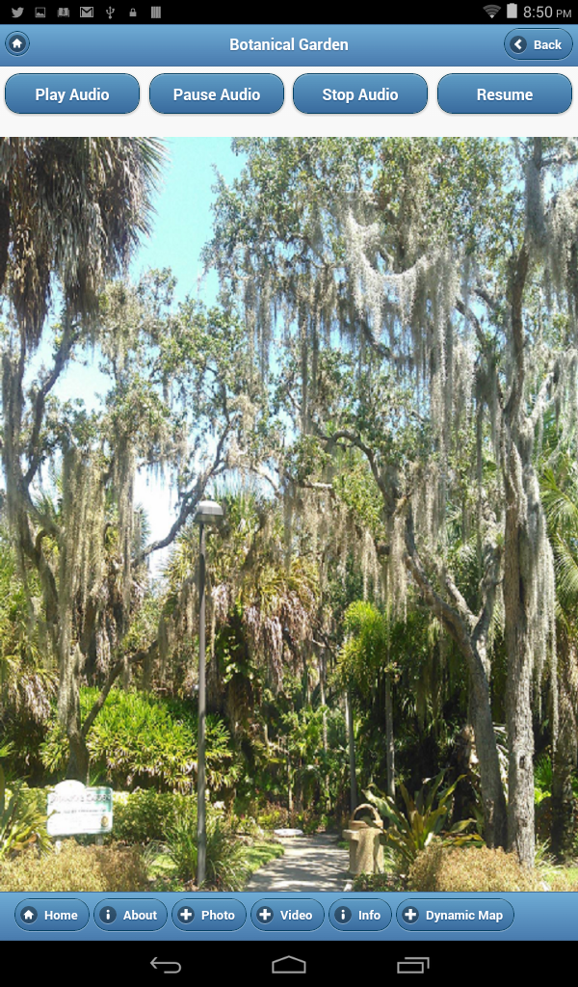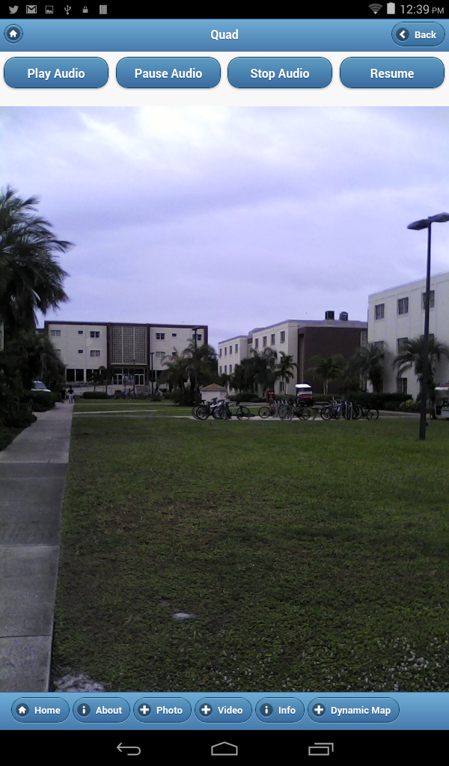

**Screen Shots 13-16:**

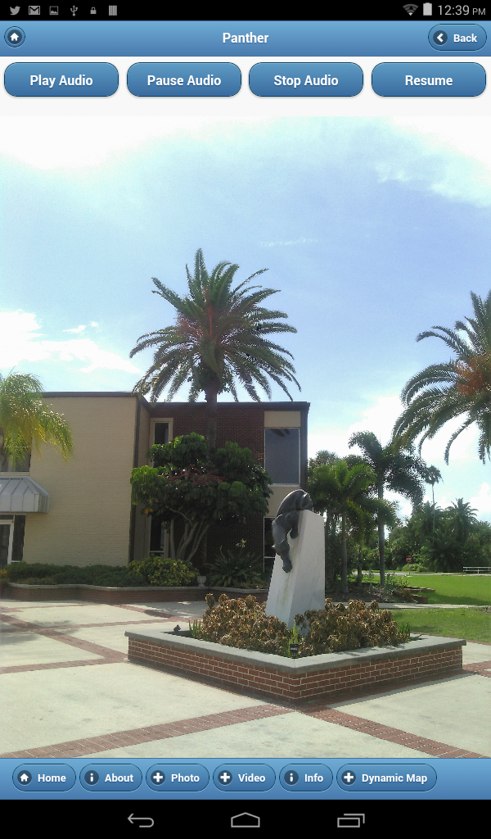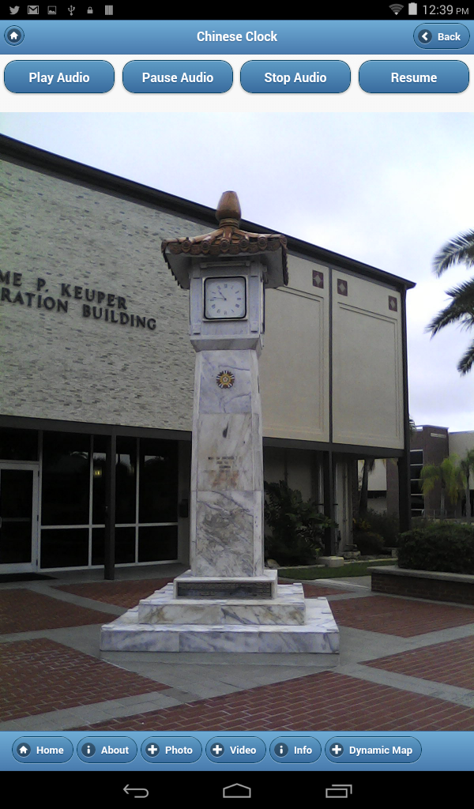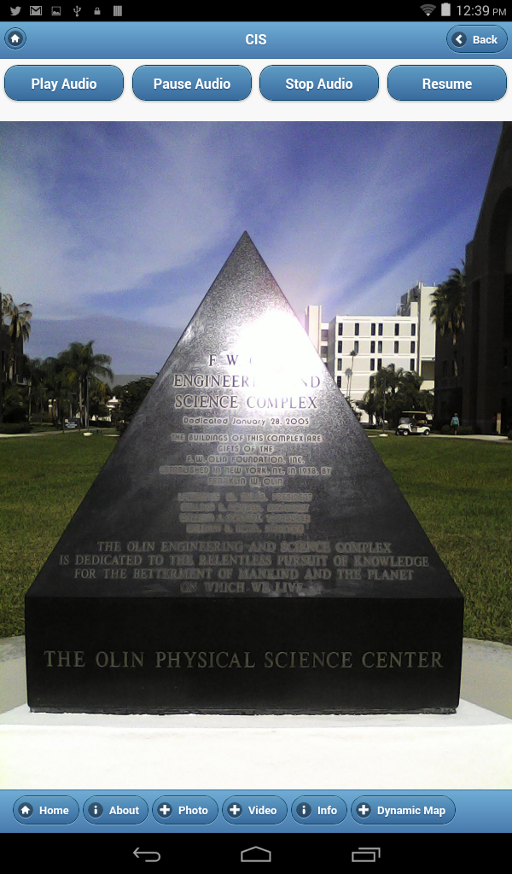 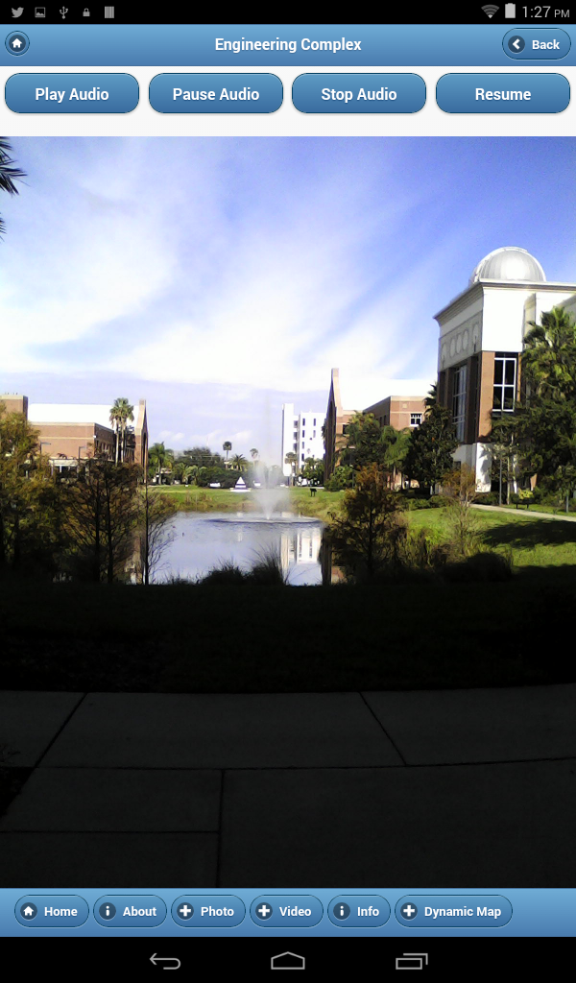

**Screen Shots 17-20:**

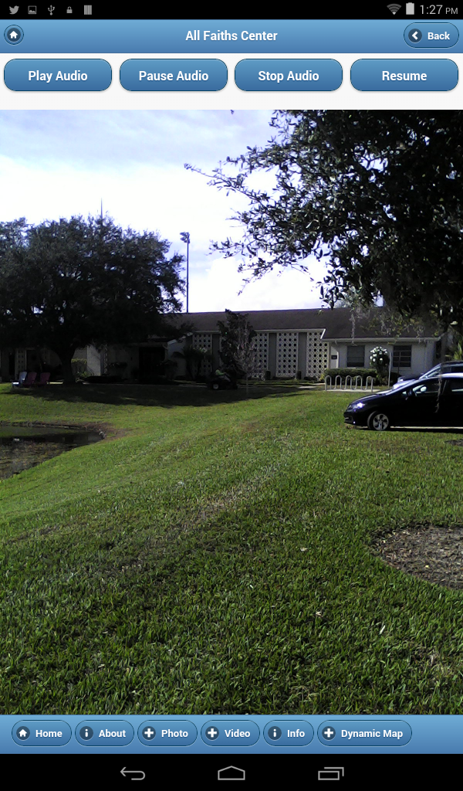 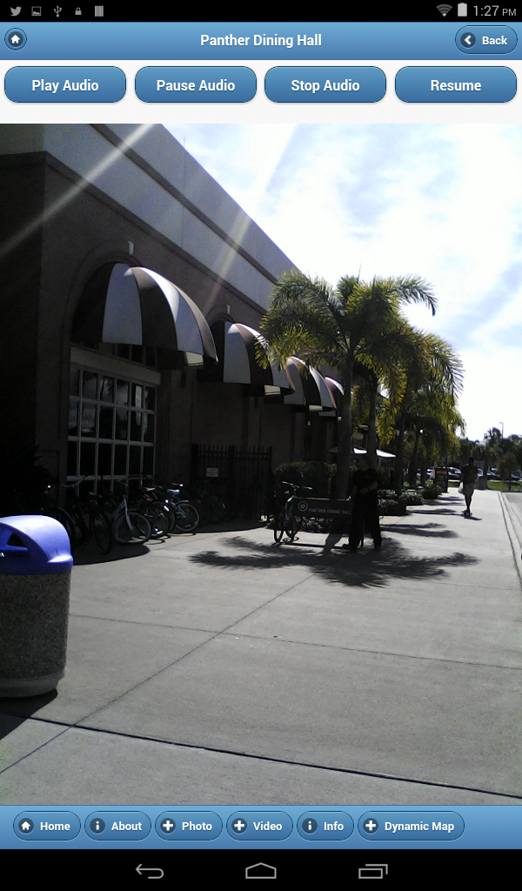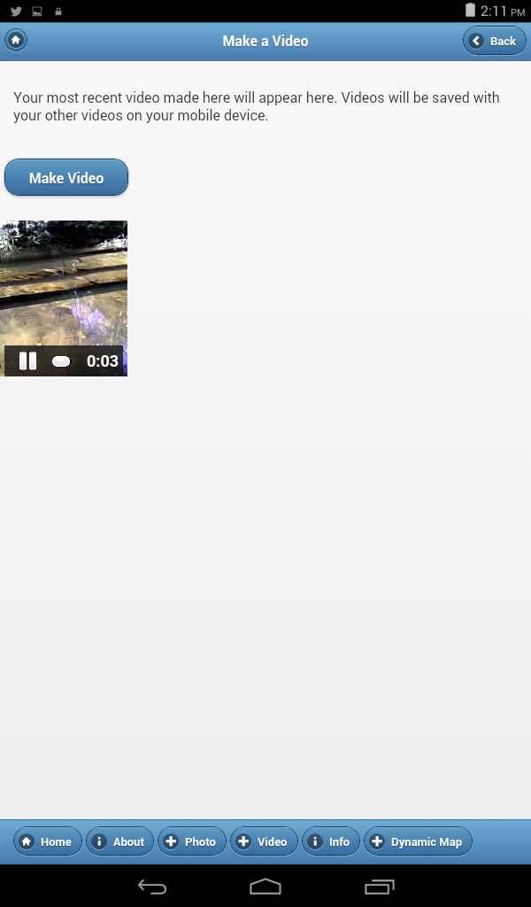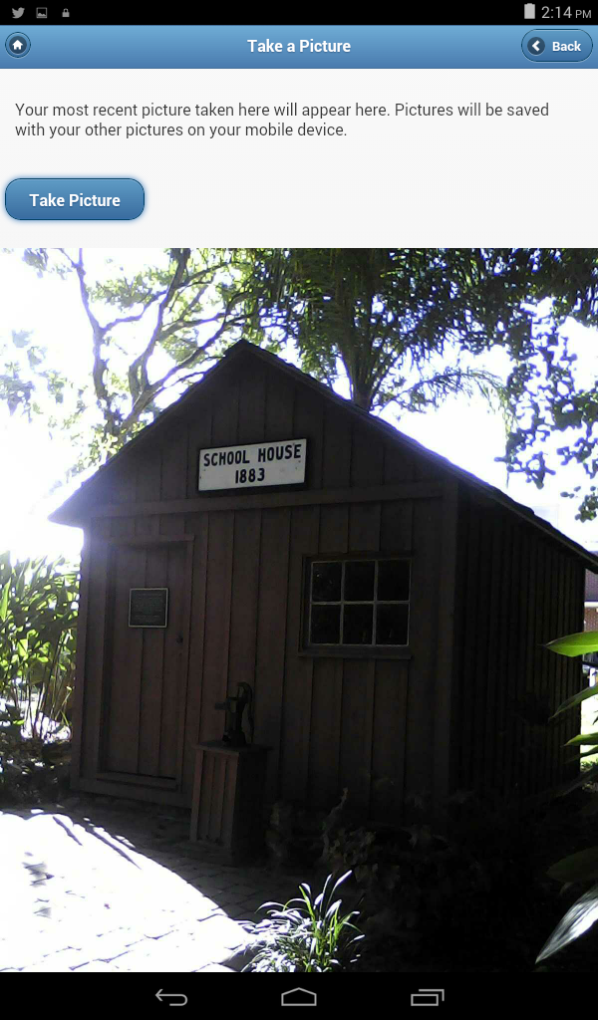

**Screen Shots 21-24:**

